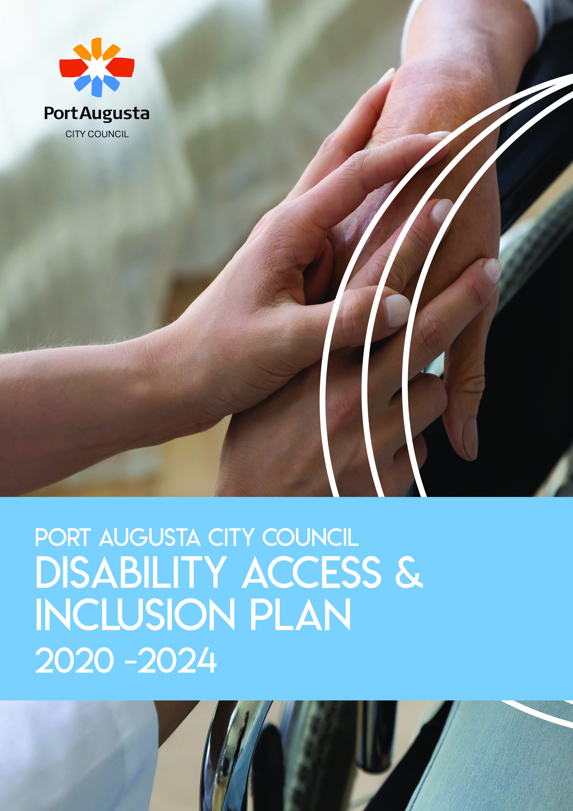

Disability Access and Inclusion
Plan (DAIP)
2020 – 2024

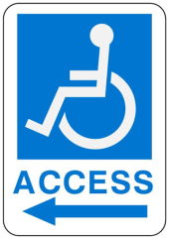

Adopted by Council on 13th October 2020

The font used in this document is Arial, which is the preferred font of Vision Australia and the Australian Royal Society for the Blind to assist some people who have a visual impairment. This report is set at their recommended minimum size of 12pt. Their recommended ideal is 18pt; however this is subject to the preferences of each individual.

TABLE OF CONTENTS

 |  |  | Page
Acknowledgement of Country  Message from the Council |  |  | 5  5
PART 1 – INTRODUCTION
1.1 | About The Port Augusta Local Government Area |  | 7
1.2 | Council Strategic Directions 2019-2029 |  | 8
1.3 | Our Aspiration |  | 8
1.4 | Managing Risk Against Disability Discrimination |  | 9
1.5 | Population and Disability Demographic Profile |  | 9
PART 2 – DEVELOPING A DISABILITY ACCESS AND INCLUSION PLAN
2.1 | Aims of the Disability Access and Inclusion Plan |  | 12
2.2 | Objectives of this Disability Access and Inclusion Plan |  | 12
2.3 | Establishing a Disability Access and Inclusion Plan |  | 13
2.4 | Relevant Legislative and Policy Framework |  | 15
2.5 | Disability Discrimination |  | 19
2.6 | Implementation |  | 20
2.7  2.8 | Evaluation and Review  Community and Stakeholder Consultation |  | 21  22
PART 3 – ACTION PLAN PRIORITIES
3.1 |  | Inclusive communities for all | 25
3.2 |  | Leadership and collaboration | 26
3.3 |  | Accessible communities | 27
3.4 |  | Learning and employment | 29

VISUAL PROMPTS

The Corporation of the City of Port Augusta (PACC) wrote this plan.
When you see the word ‘we’ it means PACC.

We have written this plan in an easy to read way. We use some pictures to explain ideas.

We have written some words in bold. We explain what these words mean within the Disability Access and Inclusion Plan Actions.

You can find the Disability Inclusion Act 2018 at https://www.legislation.sa.gov.au

You can ask for help to read this plan. A friend, family member or support person may be able to help you.

Acknowledgement of Country
“We would like to pay our respects to the traditional owners of the land on which we meet. We acknowledge their ancestors and their sharing of their country. We also pay respect to the many Aboriginal groups and cultures that work, walk and live in Port Augusta”.

Message from the Mayor:

The Port Augusta City Council Disability Access and Inclusion Plan has been developed with Council’s Strategic Directions 2019-2029 in mind. Theme 1: Community includes the desired outcome (3) “People of all ages, cultures, abilities and interests have access to services, facilities and experiences that support their health and wellbeing.”

It is structured around themes and priority areas of the Inclusive SA: State Disability Inclusion Plan 2019-2023, ensuring that Council provides and advocates on behalf of the community for fair and equitable access to services and facilities by people with a disability and their carers.

The Plan is developed in consultation with the community, including people with disabilities, service providers, Council officers and volunteers. From the information gathered, an action plan is created which demonstrates Council’s commitment to eliminating discrimination.

This Disability Access and Inclusion Plan ensures that the rights of people living with disability are upheld. People living with disability should be able to access and participate in all aspects of our society, including using mainstream services and programs. Social inclusion is fundamental to a person’s quality of life and critical to achieving positive life outcomes across all areas.

Brett Benbow
Mayor

Contact Details
Port Augusta City Council
E: admin@portaugusta.sa.gov.au P: (08) 8641 9100
A: 4 Mackay Street (PO Box 1704), PORT AUGUSTA SA 5700
W: www.portaugusta.sa.gov.au
We invite feedback on the DAIP. A link to a feedback form is below;
https://www.portaugusta.sa.gov.au/enquiries/online-forms

Port Augusta City Council has a role of ‘leader’, representing and advocating for our communities. It is also a ’provider’ of facilities, and disability access is considered in the provision of services including transport infrastructure, the Eastside Foreshore and Coastal Path, Australian Arid Lands Botanic Gardens, Wadlata Outback Centre, Central Oval Community Hub, Gladstone Square and the “Liberty Swing”, as well as multi-access toilet blocks and playgrounds .
This Disability Access and Inclusion Plan (DAIP) is available on the Port Augusta City Council website. If you require a copy in an alternative format, (such as Easy Read, large font, electronic format (disk or emailed), audio or Braille), please contact:
E: admin@portaugusta.sa.gov.au | P: (08) 8641 9100
A: 4 Mackay Street (PO Box 1704), PORT AUGUSTA SA 5700

Date: 13th October 2020

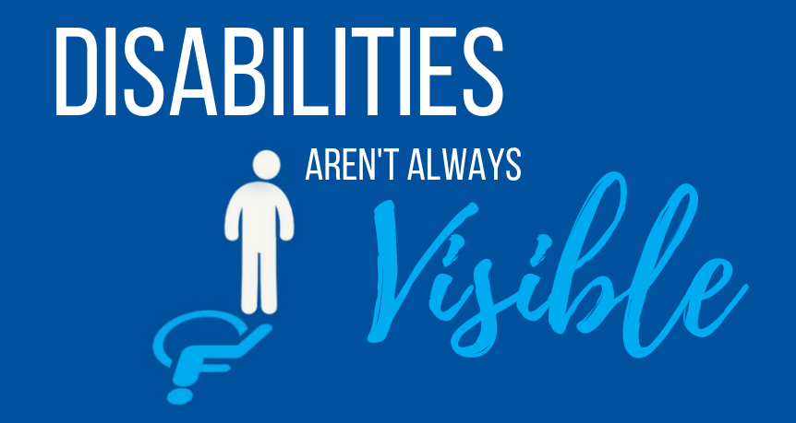
PART 1 – ABOUT THE PORT AUGUSTA CITY COUNCIL

1.1 - About The Port Augusta Local Government Area
Port Augusta City Council is located at the head of Spencer Gulf in South Australia and includes Stirling North and the seaside homes located at Commissariat Point, Blanche Harbor and Miranda and has a population of approximately 14,000 people. Council acknowledges and respects the traditional owners, their ancestors and the sharing of lands on which Port Augusta is located.
Port Augusta today is a busy regional centre and always has been, with its central location making it an important meeting place for the many and diverse Aboriginal and Torres Strait Islander groups of people who gathered to trade and exchange knowledge and skills. European settlement began in the 1840s and the town grew from a pastoral service centre and in 1878, the town became the southern terminus of a Central Australia Railway (a railway town) headed for Darwin. In 1929 the line was extended to the terminus at Alice Springs in the Northern Territory. Between 1913 and 1917, the East–West transcontinental railway was built from Port Augusta to Kalgoorlie in Western Australia.
In late 1964, Port Augusta was granted City status, and the current council was formed.
It is important to note that the City of Port Augusta has always been the focal point of the Flinders Ranges region through its connection with early exploration, the export of wool and the construction of roads and railways in this part of the State. The Flinders Ranges have an international reputation as a major tourist attraction.
The region is also rich in minerals and the potential value of new mining development is considerable, not to mention the potential benefits from the services and facilities provided in modern mining communities.
Port Augusta is fast building a reputation as a Renewably Energy Hub with a number of projects commissioned and others in planning stages featuring wind, solar and hydro power.
The elected Council comprises of the Mayor and nine Councillors, with Port Augusta City Council responsible for a diverse range of services including social programs, tourism facilities, parks and gardens, ovals, art galleries and performance centres, road infrastructure, regulatory services, street lighting, town planning, and library and information services.

Staff Profile
The Port Augusta City Council believes it has a responsibility to all its members of its community to create an employment environment which is free of discrimination and which reflects the diversity and needs of the community it serves. The Council is committed to proper principles of personnel management which will be observed in relation to employment in the administration of Council.
Staff identifying as having a disability have access to existing plans relating to Disability Access and Inclusion (e.g. workforce plans related to employment, training and retention of people living with disability).

1.2 - Council Strategic Management Plan

The Council Strategic Directions and Action Plans focus on successfully achieving its Goals and Objectives within predetermined timeframes, which commit Council to Service Delivery; Organisational Management; Community Involvement plus Linkages and Coordination, all of which can affect people with a disability and/or their carers.
Council’s Strategic Directions 2019-2029 includes the goal “We are a welcoming and inclusive community that understands, represents and preserves our unique sense of purpose and place” with a desired outcome that ”People of all ages, cultures, abilities and interests have access to services, facilities and experiences that support their health and wellbeing”.
Council acknowledges and references the Disability Inclusion Act 2018 (SA), Inclusive SA: State Disability Inclusion Plan 2019–2023, the National Disability Strategy 2010–2020 and the United Nations Convention on the Rights of Persons with Disabilities.

1.3 - Our Aspiration

Port Augusta is a growing service centre for the Outback regions of South Australia and Place of Destination in its own right, supporting a proud and vibrant community. We are a City with a long history as a Regional Hub that is able to reinvent itself.

We aspire to build on our history and become a model Regional Hub for Transport, Sustainable Industries, Mining and Defence Services, Tourism, Retail and Business, Government and Non-Government Services, Education, and Recreation and Culture. Having a critical mass is important for the future sustainability of Port Augusta. To achieve this, we seek a reversal of our loss of population from 15,621 in 1991 (ABS Census 1991) to 14,102 (ABS Statistics 2018)

1.4 – Managing Risk Against Disability Discrimination

Council is committed to maintaining and applying governance and risk management principles to ensure that any impacts to strategic and business objectives are considered and analysed. Council will adopt and implement a systematic approach to identify, assess, evaluate and treat (mitigate) risks. The risk management program involves identifying opportunities to ensure Council achieves its strategic goals whilst recording its operational risks.
Council’s Risk Management Framework includes the methods and processes used to manage risks and identify opportunities to achieve defined objectives. Risk Management is not just about the risk assessment process nor is a stand-alone discipline. In order to maximise risk management benefits and opportunities, it requires integration through Council’s entire operations.

1.5 - Population and Disability Demographic Profile

AUSTRALIAN NATIONAL OVERVIEW
People with a disability
In 2018 there were 4.4 million Australians with disability, 17.7% of the population, down from 18.3% in 2015.
- The prevalence of disability increased with age - one in nine (11.6%) people aged 0-64 years and one in two (49.6%) people aged 65 years and over had disability;
- Disability prevalence was similar for males (17.6%) and females (17.8%);
- 5.7% of all Australians had a profound or severe disability;
- Almost one-quarter (23.2%) of all people with disability reported a mental or behavioural disorder as their main condition, up from 21.5% in 2015.
Of those with disability (living in households):
- One-third (33.4%) of those aged 15 years and over had completed year 12 or equivalent, up from 31.4% in 2015;
- One in six (16.1%) aged 15 years and over had a Bachelor degree or above, up from 14.9% in 2015;
- 37.9% of those aged 15-64 years said their main source of personal income was a government pension or allowance, down from 41.9% in 2015;
- 59.7% of people had their need for assistance fully met, down from 62.1% in 2015;
- One in 10 (9.6%) aged 15 years and over had experienced discrimination in the previous 12 months because of their disability, up from 8.6% in 2015;
- Labour force participation for those aged 15-64 years has remained stable since 2015 at 53.4%, in contrast to an increase in the participation rate for people without disability (84.1%);
- 11.4% of those with a profound or severe disability (aged 15-64 years) were working full-time up from 7.9% in 2015.
Older people
One in every six Australians (15.9% or 3.9 million people) was aged 65 years and over (up from 15.1% in 2015).
- Most older Australians (persons aged 65 years and over) were living in households (95.3%), with 4.6% living in cared accommodation;
- Half (49.6%) of all older Australians had disability (similar to 2015);
- 1.3 million older Australians living at home needed some assistance with everyday activities, and of these, almost two-thirds (65.9%) had their need fully met (down from 69.2% in 2015);
- Two-thirds (68.1%) of older Australians (who reported income) lived in a low income household (a household earning less than $756 per week);
- Almost all older Australians had participated in social activities at home (97.4%) or outside their home (94.4%) in the previous three months.
Indigenous Australians with disability
Among Indigenous Australians living in private households in 2015:
24% (125,000 people) were living with disability—defined as any limitation, restriction or impairment which restricts a person’s everyday activities, and has lasted, or is likely to last, for at least 6 months;
7.3% (38,100) had severe or profound disability—meaning they sometimes or always needed help with daily activities related to self-care, mobility or communication (ABS 2017);
These estimates are based on data from the Australian Bureau of Statistics (ABS) 2015 Survey of Disability, Ageing and Carers (SDAC).
Carers

There were 2.65 million carers, representing 10.8% of all Australians (down from 11.6% in 2015).
- Females were more likely to be carers (12.3% of all females) than males (9.3% of all males);
- There were 235,300 young carers (under the age of 25), down from 274,700 in 2015;
- 3.5% of all Australians were primary carers;
- Seven in ten (71.8%) primary carers were women;
- Over one-third (37.4%) of primary carers had disability, twice the rate of non-carers (15.3%);
- The most common reason primary carers gave for taking on a caring role was a sense of family responsibility (70.1% of all primary carers);
- Half (50.2%) of all carers lived in a household in the lowest two equal gross income, twice that of non-carers (25.6%).
PORT AUGUSTA COUNCIL OVERVIEW

To plan for services provided by Council, it is considered imperative that the population demographic relevant to this plan, is well known by Council.

The 2018 Australian Bureau Statistics indicates that the Port Augusta Council has a total population of 14,102, of which approximately:

12% received the Age Pension
12.6% provide unpaid care, help or assistance to family members or others
5.7% receive the Disability Support Pension

This equates to approximately 30% of our population.

In 2018 Port Augusta had 375,000 visitors in the area, of which 57% visited for holiday or leisure (Tourism Research Australia).

Given the National data, one may assume that in 2018 for example 75,000 visitors to the Port Augusta Council area may have had a disability and or be a carer.

This action plan proactively guides services to our community and visitors.

All persons, Disability rates by age
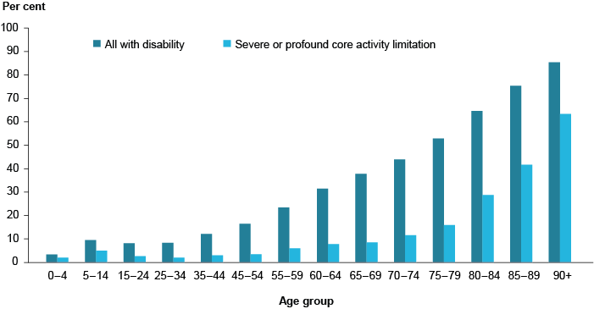

PART 2 – DEVELOPING AN ACCESS AND INCLUSION
PLAN

2.1 - Aim of This Disability Access and Inclusion Plan

The aim of this Plan is to assist Council to identify and remove barriers in policies, programs and services which exclude people living with a disability, and to meet its obligations under the Disability Discrimination Act 1992 and the SA Disability Inclusion Act 2018.

In addition to this, the plan process shall:

- Acknowledge and address the risks that relate to priority groups living with disability: women, children, Aboriginal and Torres Strait Islander people and culturally and linguistically diverse people;
- Promote and improve access for all;
- Build an inclusive community for all people which respects the dignity and values the diversity of individuals;
- Strengthen our community;
- Ensure the protection of equal rights, the right to participate in all aspects of community life and to ensure the right of equal access to services, resources and facilities provided by Council, in its roles as a purchaser, service provider, policy adviser, planner, regulator, responsible employer and advocator.

2.2 - Objectives of This Disability Access and Inclusion
Plan

The objectives of this Plan are to:

- Assist Council to better meet the needs of people with a disability who live, work and visit the region;
- Assist Council to meet its legislative requirements under the Disability Discrimination Act, 1992;
- Foster a region where people with a disability are afforded the same opportunities as the broader community;
- Improve access for people living with a disability to Council’s services and facilities;
- Encourage participation by people, regardless of ability, in Council’s activities;
- Promote positive and inclusive images of people living with a disability within Council and the community;
- Enhance the relationship between Council and people living with disabilities in the area;
- Promote and increase awareness of Council staff and the broader community of the rights and needs of people living with disabilities;
- Focus on practical, achievable and deliverable initiatives to enhance access to services, physical infrastructure and public places.

2.3 - Establishing a Disability Access and Inclusion Action Plan

All Council services are covered by the Disability Discrimination Act (DDA) 1992 and the Inclusive SA: State Disability Inclusion Plan 2019-2023, including:

- Public facilities such as parks, Council offices, etc
- Maintenance of road networks and footpath systems
- Social programs
- Ryan Mitchell Swim Centre
- Library and information services
- Tourism facilities
- Planning and approval mechanisms
- Council meetings
- Council employment practices

The development of a Disability Access and Inclusion Action Plan represents a commitment by the Port Augusta City Council which will help ensure social inclusion and access for all residents and visitors.

The Policy and Action Plan clearly identifies Council’s commitment, operational framework and stated intent towards facilitating and providing an inclusive community.

This can provide many benefits including increased opportunities for social inclusion, improved physical access to facilities and buildings, enhanced community and individual wellbeing and a greater recognition of the diversity of the Port Augusta residents and visitors.

In developing this Plan, the following was included, but not limited to:

A Review of Current Activities
- The Council Strategic Directions 2019-2029 and Four Year Priority Action Plan;
- The range of potential service users and employees in the Council area;
- The changing profile of the local community and collection of information;
- Numbers of people and their types of disabilities.

Physical Barriers

- All the areas to which service users and employees should be entitled to have access;
- Physical structures which may act as barriers to people with limited mobility;
- Structures designed to deliver services, such as customer information counters and display units;
- Décor which may be confusing or disorientating to people living with a disability affecting their vision;
- Non visual guides to assist people living with a disability in using Council premises;
- Ways of assisting people with a disability to move through a space in times of emergency and evacuation, including such things as visual fire alarms for people who are deaf or hearing impaired.

Communication Barriers

- Alternatives for the advertising of Council services in ways that ensure accessibility to people living with disabilities;
- Alternative presentation of standard Council forms;
- Access to computer technology in ways which can be used by people living with disabilities;
- Use of current technology to enable individuals to access Council meetings and use visual and audio enhancements.

Attitudinal Barriers

- Commit to a process for the understanding by all staff, volunteers and elected members, of the implications of the Disability Access and Inclusion Plan (DAIP).
- Ensure all relevant Council Policies are Disability Discrimination Act (DDA) 1992 and the Inclusive SA: State Disability Inclusion Plan 2019-2023 inclusive.
- Set realistic, measurable goals and targets with achievable timelines based on collected data and allocate responsibility in liaison with responsible officers and Council committees.

In order to fulfil the requirements of the Disability Inclusion (Transitional Arrangements) Regulations 2018 (SA) Council will notify the Chief Executive of the Department of Human Services when the DAIP is published on its website.

This plan also considered a previous and comprehensive BCA and DDA audit of many Council buildings which identified actions which need to be undertaken to provide appropriate access for all, optimising the use of Council community resources.

2.4 - Relevant Legislative and Policy Framework

Federal and State Legislation require the planning, development and implementation of processes which fulfil Council’s legal and moral obligations when providing access to all citizens and visitors within the Council area.

Relevant Federal and State legislation is outlined below, but is not limited to:

Commonwealth Government

Disability Discrimination Act (DDA) 1992

The Federal Disability Discrimination Act 1992 came into effect on the 1st March 1993.

It provides uniform protection against unfair or unfavourable treatment for people with disabilities in Australia, and seeks to fill the gaps in State and Territory legislation. Its objectives are to:

- Eliminate, as far as possible, discrimination against persons on the grounds of disability;
- Ensure, as far as practicable, that people with disabilities have the same rights to equality before the law as the rest of the community, and
- Promote recognition and acceptance within the community of the principles that people with a disability have the same fundamental rights as the rest of the community.

Disability Inclusion Act 2018 (SA)

An Act to promote the full inclusion in the community of people with disability; to assist people with disability to achieve their full potential as equal citizens; to promote improved access to mainstream supports and services by people with disability; to provide for the screening of persons who want to work or volunteer with people with disability and to prohibit those who pose an unacceptable risk to people with disability from working or volunteering with them; to provide for a community visitor scheme; to provide for responsibilities of the State during and following the transition to the National Disability Insurance Scheme; and for other purposes.
Inclusive SA: State Disability Inclusion Plan 2019-2023
The plan brings State Government agencies and local councils together to reduce the barriers faced by people living with disability.
Inclusive SA sets out the priorities and actions for the next four years under the following themes:
- Inclusive communities for all
- Leadership and collaboration
- Accessible communities
- Learning and employment
The priorities and actions set out in Inclusive SA are the first steps to improving access and inclusion for people living with disability.

The National Disability Strategy 2010-2020

The National Disability Strategy (the Strategy) sets out a ten year national plan for improving life for Australians with disability, their families and carers. It draws on the findings of extensive consultation conducted in 2008-09 by the National people with Disabilities and Carer Council and reported in Shut Out: The Experience of People with Disabilities and their Families in Australia (2009).The report is available at:

http://www.fahcsia.gov.au/sa/disability/pubs/policy/community_consult/pages/default.aspx:

United Nations Convention on the Rights of Persons with Disabilities

The Convention on the Rights of Persons with Disabilities is an international human rights treaty of the United Nations intended to protect the rights and dignity of people with disabilities.

Disability Services Act 1986

This is a Commonwealth Act which ensures the rights of people with a disability to access services and to be treated with dignity.

Building Code of Australia

The Building Code of Australia, (BCA) in conjunction with the DDA, applies to new buildings undergoing significant refurbishment or alteration. The BCA is a comprehensive statement of the technical requirements relevant to the design and construction of buildings and other related structures and facilities.

The specific section or Part of the BCA that relates to disability access is Part D3. This Part outlines the minimum required for buildings to facilitate as far as is reasonable disability access to and within certain building classifications

Standard AS 1428 is directly referenced under the BCA. Compliance with a range of access provision is required.

Australian Standard 1428 – Design for Access and Mobility

AS 1428 is an important Building Code of Australia (BCA) reference standard which prescribes requirements for physical access which must be adhered to in the planning, development and construction of all buildings and facilities.

Other Australian and International Standards (AS and ISO)
Various Standards set out requirements that must be referred to when making decisions that impact on people with disabilities.

The Australian Human Rights Commission

The Australian Human Rights Commission Act 1986 (formerly called the Human Rights and Equal Opportunity Commission Act 1986) established the Human Rights and Equal
Opportunity Commission (now known as the Australian Human Rights Commission) and gives it functions in relation to the following international instruments:

- International Covenant on Civil and Political Rights (ICCPR)
- Convention Concerning Discrimination in Respect of Employment and Occupation
- Convention on the Rights of Persons with Disabilities
- Convention on the Rights of the Child
- Declaration of the Rights of the Child
- Declaration on the Rights of Disabled Persons
- Declaration on the Rights of Mentally Retarded Persons, and
- Declaration on the Elimination of All Forms of Intolerance and of Discrimination Based on Religion or Belief.

The AHRC is responsible for administering the Disability Discrimination Act 1992, and has developed notes and guidelines on Access to Premises.

South Australian State Government

Local Government Act 1999

Detailing the statutory obligations of Local Government in relation to its role, functions and objectives Chap 1 Sec 3, Chap 2, Sect 6 and 7.

Equal Opportunity Act 1984

The purpose of the Equal Opportunity Act 1984 (SA) is to promote equality of opportunity for all South Australians. It aims to prevent discrimination against people and to give them a fair chance to take part in economic and community life.

South Australia Disability Services Act, 1993

Act to provide for the principles that are to be applied with respect to people with disabilities; funding and provision of disability services.

Development Act 1993

Part 1 Sec 3 (f) (g) to regulate the design and construction of buildings.

Mental Health Act 2009

An Act which provides for the treatment, care and rehabilitation of people with serious mental illness with the goal of bringing about their recovery as far as is possible; to confer powers to make orders for community treatment, or detention and treatment of such people where required; to provide protections of the freedom and legal rights of mentally ill people.

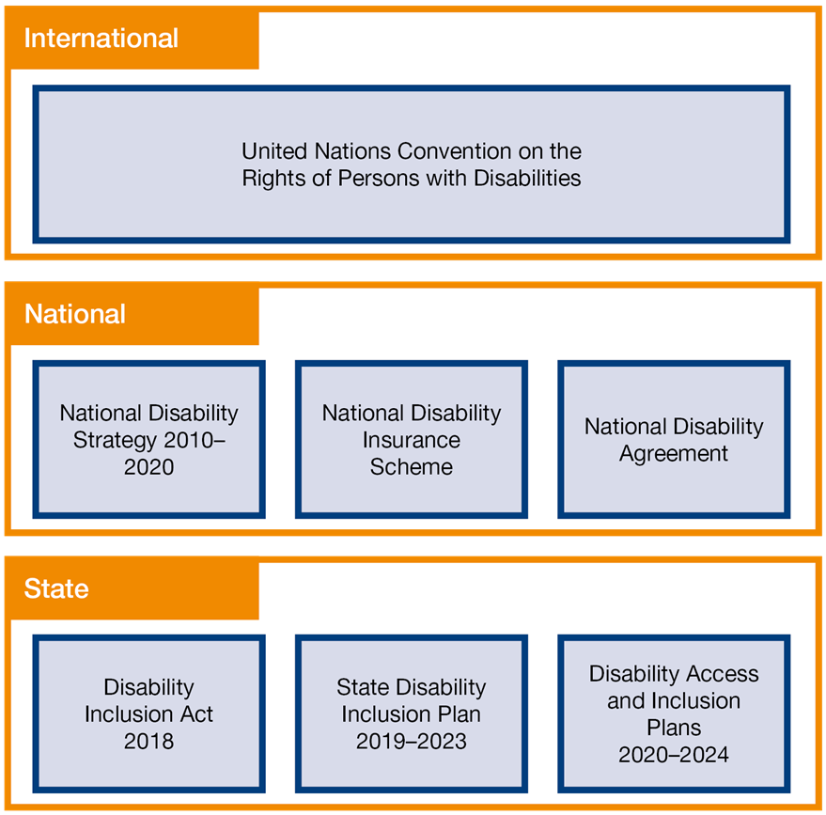
Source: DHS DAIP Guideline

2.5 - Disability Discrimination

Disability

The Federal Disability Discrimination Act 1992 (DDA) and the SA Disability Inclusion Act 2018 provides protection for everyone in Australia against discrimination based on disability. It encourages everyone to be involved in implementing the Act and to share in the overall benefits to the community and the economy that flow from participation by the widest range of people.

Disability discrimination happens when people with a disability are treated less fairly than people without a disability. Disability discrimination also occurs when people are treated less fairly because they are relatives, friends, carers, co-workers or associates of a person with a disability.

The definition of "disability" in the DDA includes:
- Physical
- Intellectual
- Psychiatric
- Sensory
- Neurological,
- Learning disabilities,
- Physical disfigurement,
- The presence in the body of disease-causing organisms

This broad definition is meant to ensure that everyone with a disability is protected from discrimination.

Additionally, the DAIP covers disability which people:
- Have now
- Had in the past (for example: a past episode of mental illness)
- May have in the future (e.g. a family history of a disability which a person may also develop)
- Are believed to have (for example: if people think someone has HIV/AIDS)

The Act also covers people with a disability who may be discriminated against because they:
- Are accompanied by an assistant, interpreter or reader
- Are accompanied by a trained animal, such as a guide or hearing dog, or use equipment or an aid, such as a wheelchair or a hearing aid

Further the DAIP protects people who have some form of personal connection with a person with a disability, like relatives, friends, carers and co-workers, if they are discriminated against because of that connection or relationship.

Discrimination

Discrimination can be direct or indirect.

Direct discrimination occurs when a person with a disability receives less favourable treatment than a person without a disability would receive in the same or similar circumstances.

Indirect discrimination occurs when there is a requirement, condition or practice in force that applies to everyone but unfairly excludes or disadvantages people with a disability because they are unable, or find it difficult, to comply with the requirement, condition or practice due to the disability.

2.6 - Implementation

Following Council’s adoption of the plan it will be:

- Distributed to Council Elected Members, Managers/Supervisors, staff, and volunteers for action
- Registered with the Department of Human Services and the Human Rights and Equal Opportunity Commission
- Notified to the public and made available online and at the Civic Centre.

Responsibilities of implementation

The Council is responsible for:

- Endorsing the plan
- Ensuring that all Elected Members are aware of the plan as part of their induction
- Overseeing the development and implementation of the plan
- Ensuring that there is an equitable allocation of resources
- Ensuring that all Council decisions reflect the plan’s principles and priorities

Council Managers/Supervisors, Staff and Volunteers are responsible for:

- Facilitating the provision of information about the plan and its implementation.
- Ensuring that the plan is implemented across all Councils activities and that goals are achieved
- Coordinating the implementation within their areas of responsibilities
- Nominating and releasing relevant officers to attend disability awareness and training programs
- Ensuring that people with disabilities are consulted effectively
- Ensuring that budgets are allocated equitably on needs-based planning
- Providing regular reports on the achievement of the goals
- Facilitating the development of the plan
- Liaising with people with a disability in the community and their carers, Council elected members, employees and volunteers
- Monitoring the implementation of the plan and presenting regular reports
- Advising and commenting on the implementation of the plan as required
- Assisting in the evaluation of the plan

2.7 – Evaluation and Review

The plan will be evaluated through the following processes:

- Council staff will be called on to report on the outcomes against the performance indicators

- This will be documented and provided to Council and made available to the community via the website

- The opportunity for the community to provide feedback in relation to the progress of the plan will be given by open invitation for evaluative purposes close to the plan’s completion. This will also serve the function of preparing for the next plan

- Community members throughout the term of the plan can lodge comments to the Council about its progress. Council’s response will be made according to the community contacts, correspondence and customer services guidelines.

The overall Plan will be reviewed after four years to ensure that legislative intent and statutory requirements are being satisfied.

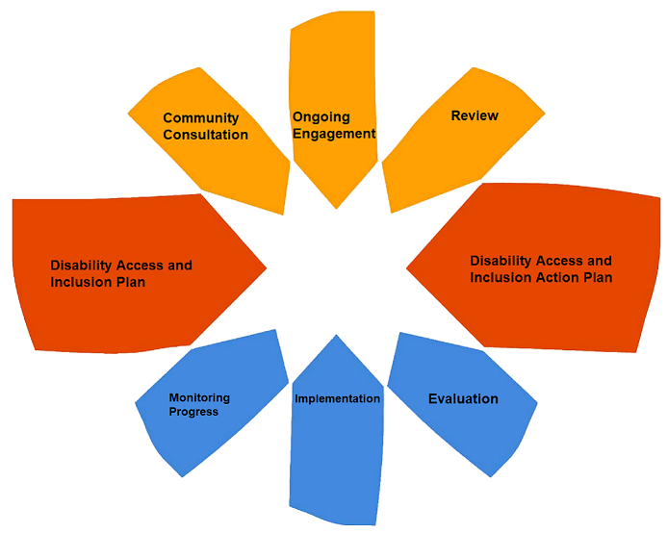

2.8 - Community and Stakeholder Consultation

Under regulation 9(4) of the Disability Inclusion Regulations 2019 (SA) in order to develop the Disability Access and Inclusion Plan in partnership with the local community, Council will continue to undertake consultation and feedback opportunities which will provide a forum for people to actively contribute to the development of the Plan.

Consequently, in addition to Elected Members, the Council staff and volunteers who contribute to the consultation include staff from departments such as: Town Planning; Community & Recreational Facilities; Infrastructure; Tourism, Community Services; City and Cultural Services; City Management; Building Approvals; Customer Service and Finance.

Acknowledgments

Likewise, extensive community representation will continue to include individuals and local service organisations, and all their contributions are acknowledged, from the local Child Care providers; Port Augusta Special School, Inclusive Basketball Port Augusta, members of the “Partnerships in Positive Ageing” Aged Care Network, CARA; Community Bridging Services; Orana, Hearing Services, Mission Australia (NDIS Local Partner), Port Augusta Senior Citizens Club; Red Cross; Life Without Barriers; other local NDIS providers; Carers SA; Pika Wiya Health Service and Priority Groups living with disability: women, children, Aboriginal and Torres Strait Islander people and culturally and linguistically diverse people.

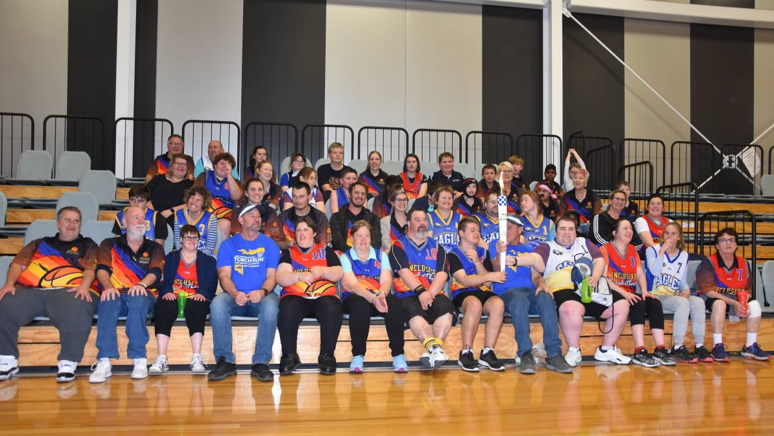
E AND INCLUSION POLICY
PART 3 – DISABILITY ACCESS AND INCLUSION ACTION PLAN
The Port Augusta Council Disability Access and Inclusion Plan is structured around the themes and priority areas of the Inclusive SA: State Disability Inclusion Plan 2019-2023.

1: Inclusive communities for all
Social inclusion is a priority for people living with disability as it affects all aspects of their lives. It is our aim that the contributions and rights of people living with disability are valued and understood by all South Australians and that their rights are promoted, upheld and protected. We also want to ensure that people living with disability are supported to advocate for their own rights.
Priority 1: Involvement in the community
Priority 2: Improving community understanding and awareness
Priority 3: Promoting the rights of people living with disability

2: Leadership and collaboration
People living with disability want to have a greater role in leading and contributing to government and community decision-making. It is our aim that the perspectives of people living with disability are actively sought and that they are supported to participate meaningfully in government and community consultation and engagement activities.
Priority 4: Participation in decision-making
Priority 5: Leadership and raising profile
Priority 6: Engagement and consultation

3: Accessible communities
The accessibility of the built environment, quality services and information is key to ensuring people living with disability are included and have the opportunity to equally participate in all aspects of community life. It is our aim to increase accessibility to public and community infrastructure, transport, services, information, sport and recreation and the greater community.
Priority 7: Universal Design across South Australia
Priority 8: Accessible and available information
Priority 9: Access to services

4: Learning and employment
Workforce participation is fundamental to social inclusion. It provides economic independence and choice, social connections and friendships, value, identity and belonging. It is our aim that people living with disability have access to inclusive places of study and that education and training provides pathways to meaningful and inclusive employment and volunteering opportunities.
Priority 10: Better supports within educational and training settings
Priority 11: Skill development through volunteering and support in navigating the pathway between learning and earning
Priority 12: Improved access to employment opportunities and better support within workplaces

Key Performance Indicators (KPI’s)

Each action has been delegated a KPI rating which follow the guidelines below:

High

Those areas which are identified as an urgent need (because they are frequently used by members of the community who are disabled), and should be completed between 2020 – 2021.

Medium

Those areas identified which are not as urgent but would still benefit people with a disability and other population groups if the recommendations were carried out. They should be completed by the year 2022.

Low or Ongoing

Those areas which require ongoing action to meet the needs of our diverse community.

As needs basis only: Those areas which are rarely if ever accessed by people with disability, and have a narrow focus of people who access it. Upgrades only assessed on an as needs basis. This category also includes facilities/services for which upgrades would cause unjustifiable hardship. It also includes buildings which may be sold and abandoned in the very near future; therefore extensive upgrades are not feasible. If not ongoing, actions should be addressed by 2024.

KPI’s will also provide comments on achievements based on actions.
Whilst the Chief Executive Officer and Directors are noted as responsible for some actions, it is their responsibility to delegate the Actions to their relevant staff in addition to making them accountable for required outcomes.

Actions
The Port Augusta City Council Disability Access and Inclusion Plan is structured around the themes and priority areas of the Inclusive SA: State Disability Inclusion Plan 2019–2023.
1: Inclusive communities for all
Social inclusion is a priority for people living with disability as it affects all aspects of their lives. It is our aim that the contributions and rights of people living with disability are valued and understood by all South Australians and that their rights are promoted, upheld and protected. We also want to ensure that people living with disability are supported to advocate for their own rights.
Priority 1: Involvement in the community
Priority 2: Improving community understanding and awareness
Priority 3: Promoting the rights of people living with disability

Action | State Plan Priority # | Responsibility | Timeframe Priority  H M L O | Measurable Target
Council’s Strategic Planning includes consideration of people with disabilities | 1 | Council  Management Group | L | Council’s Strategic Plan includes objectives relating to improving access and inclusion.
Council events to be inclusive. | 1 | Director Corporate & Community Services | M | Strategies introduced to improve access and inclusion to sport, recreation and cultural events/facilities.
Ensure Management, staff and volunteer awareness of the DDA and disability issues | 2 | Human Resources  Management Group | L | Disability awareness training for all staff.
Source grants funding opportunities to implement recommendations of the DAIP. | 3 | Management Group | M | Continue applying for grant funds appropriate to disability access.

2: Leadership and collaboration
People living with disability want to have a greater role in leading and contributing to government and community decision-making. It is our aim that the perspectives of people living with disability are actively sought and that they are supported to participate meaningfully in government and community consultation and engagement activities.
Priority 4: Participation in decision-making
Priority 5: Leadership and raising profile
Priority 6: Engagement and consultation
Action | State Plan Priority # | Responsibility | Timeframe Priority  H M L O | Measurable Target
Appropriate options of communicating all Council meetings. | 4 | Management Group | H | Statistics of people living with disability that were engaged and consulted on issues.
Provide important insights into disability by inviting Community members with lived experience to have an active voice. | 5 | Chief Executive Officer  and Directors | H | Development of a contact list of community members with lived experience to form a reference group
Council will consult with Disability Agencies, Networks and Priority Groups living with disability: women, children, Aboriginal and Torres Strait Islander people and culturally and linguistically diverse people when developing/reviewing community plans. | 6 | Management Group | O | Consultation and engagement practices to ensure people living with disability are engaged and consulted.

3: Accessible communities
The accessibility of the built environment, quality services and information is key to ensuring people living with disability are included and have the opportunity to equally participate in all aspects of community life. It is our aim to increase accessibility to public and community infrastructure, transport, services, information, sport and recreation and the greater community.
Priority 7: Universal Design across South Australia
Priority 8: Accessible and available information
Priority 9: Access to services

Action | State Plan Priority # | Responsibility | Timeframe | Measurable Target
1 Incorporate Universal Design principles in criteria for all new building and public projects and planning for programs, services and events | 7 | Management Group | M | Universal design policy developed and embedded in the organisation
2 Develop Universal Design training plans for staff and contractors | 7 | Management Group | M | Universal Design training plan developed  .
3 Review of availability of accessible car parks | 7 | Manager Infrastructure | M | Accessible car park review completed
4 Encourage and support tourism infrastructure, services and information that is accessible to the community and visitors. | 8 | Manager Tourism Facilities | M | Continuous improvement of access and inclusion to tourism infrastructure and information regarding accessible accommodation and tourist experiences.

Action | State Plan Priority # | Responsibility | Timeframe | Measurable Target
5 Ensure all Council buildings and facilities are access compliant. | 9 | Management Group | M | Measures undertaken to ensure facilities, meetings and activities are accessible by all
6. Ensure Council programs are accessible and inclusive. | 9 | Management Group | M | Internal audit of accessibility of Council programs.

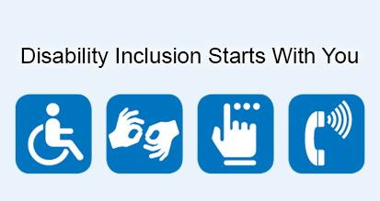

4: Learning and employment
Workforce participation is fundamental to social inclusion. It provides economic independence and choice, social connections and friendships, value, identity and belonging. It is our aim that people living with disability have access to inclusive places of study and that education and training provides pathways to meaningful and inclusive employment and volunteering opportunities.
Priority 10: Better supports within educational and training settings
Priority 11: Skill development through volunteering and support in navigating the pathway between learning and earning
Priority 12: Improved access to employment opportunities and better support within workplaces
Action | State Plan Priority # | Responsibility | Timeframe | Measurable Target
1 Provide a range of work experience and training opportunities for people with disabilities where possible. | 10 | Management Group and Human Resources | L | Increasing employment, volunteering and work experience opportunities for people living with disability.
2 Advocate for employment opportunities for people with disabilities within Port Augusta. | 11 | Management Group and Human Resources | L | Measures taken to engage people living with disability that enables them to gain skills and experience.
3 Ensure that Council recruitment and employment processes are transparent, accessible for all and DDA compliant. | 12 | Management Group and Human Resources | L | Internal audit of HR policies and processes.

